Finance SSB Users Upload and View documents in OnBase

Click on the Self-Service Icon
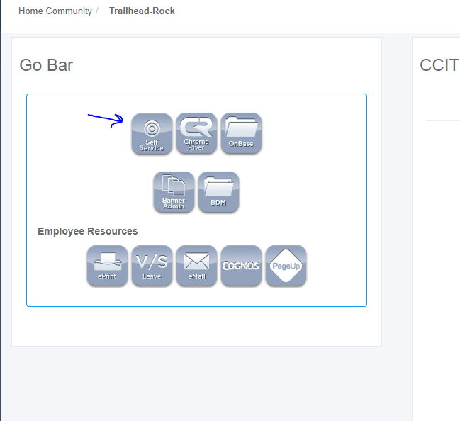

Click on the Finance Tab. If you are not a Finance User you will not have this tab. If you think you should be a Finance user but are not, contact the Controller’s Office. From the finance tab, select View Document.
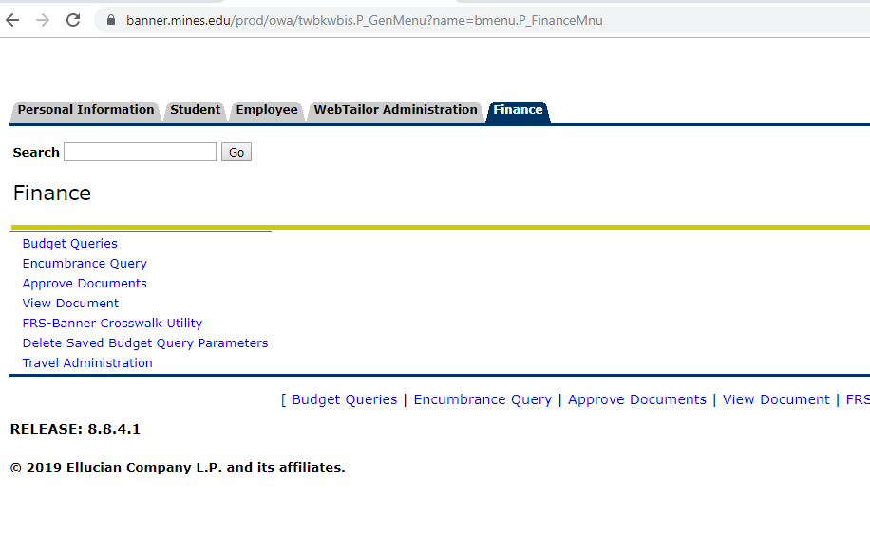
Type in a requisition or a purchase order number. Only these two document types are using OnBase through SSB. Then click View document.
If the document does not display, you do not have access to the document. Contact your supervisor to request fund/org access.

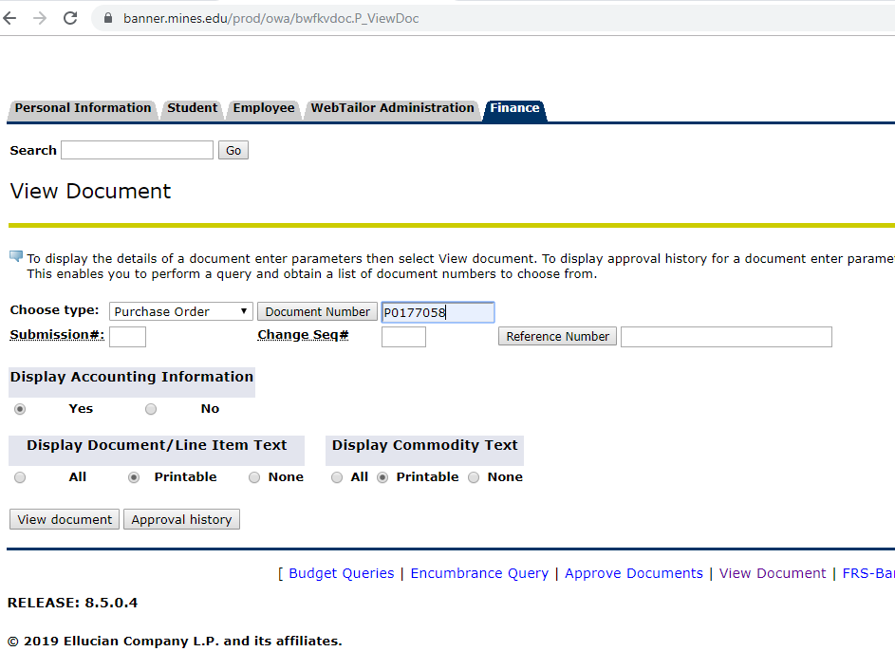

Click upload or Display Documents. If Display documents does not appear, there are no documents to display. Contact Procurement if you think there should be a document to display.
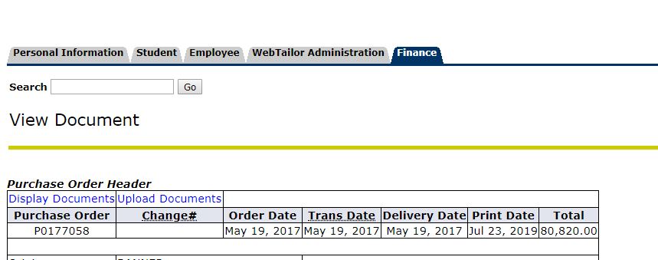

If you are not already logged into OnBase Web, you will be prompted to log in. Enter your
Multi-pass id and password.

